**Manual**

**Of**

**AL NAHDI SAFARIS**

**Website**

1. **SIGNUP**

Step 1 => For new users, click on the login page from the homepage.

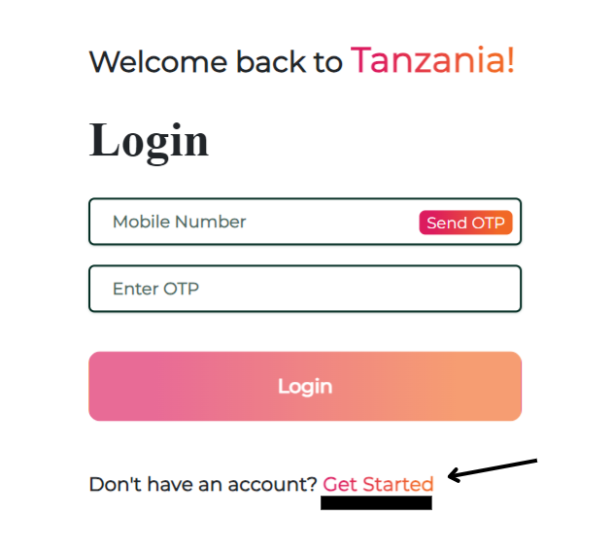

Step 2 => Click on “Get Started”.

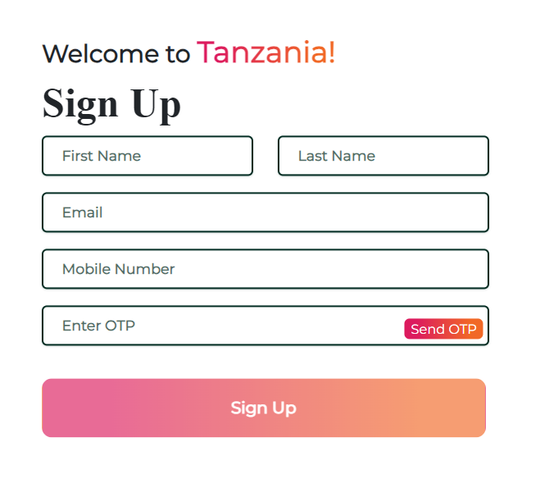

Step 3 => Enter your details in the fields. Click on “Send OTP” to verify your information. The time duration is **30 seconds** to fill the OTP.

Step 4 => Default OTP is **“1234”.** After entering the OTP, your account is created.

1. **LOGIN**

Step 1 => Enter your phone number.

Step 2 => Click on the send OTP Button to request OTP.

Step 3 => Enter “1234” as the default OTP.

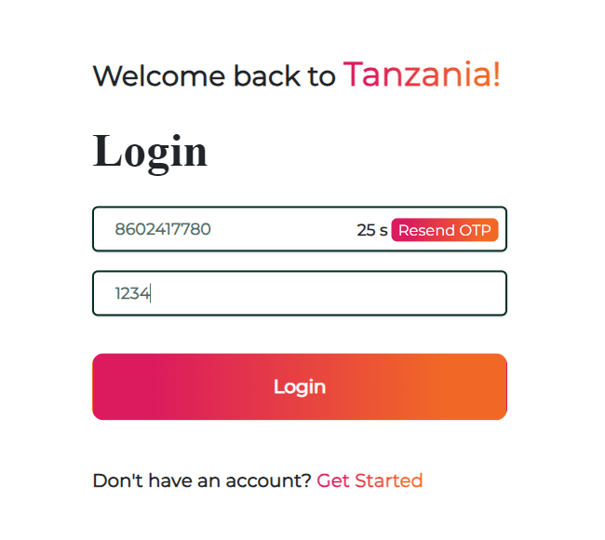

Step 4 => You are now redirected to your ‘Account Dashboard’.

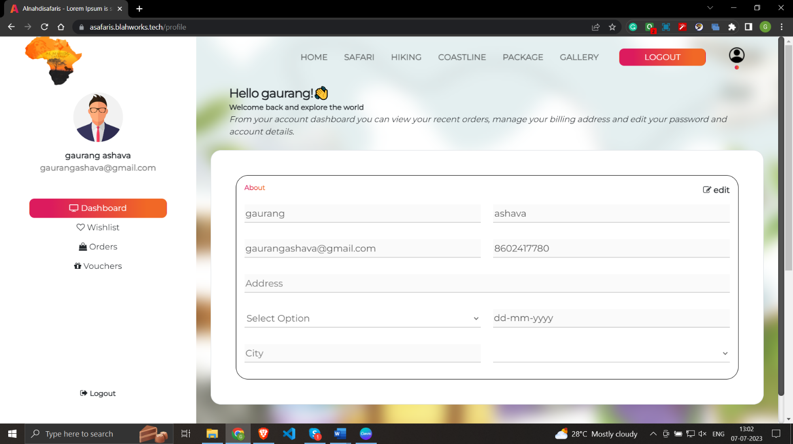Step 5 => In this section, you can manage your billing address, change your password, and account details.

1. **WISHLIST/ORDERS & VOUCHERS**

Step 1=> Here you can see your Wishlist, your Orders, and some Vouchers as well.

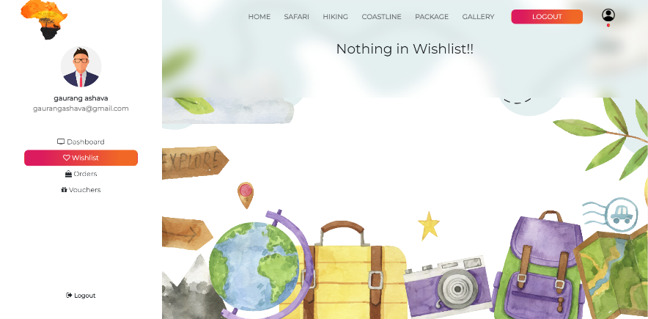

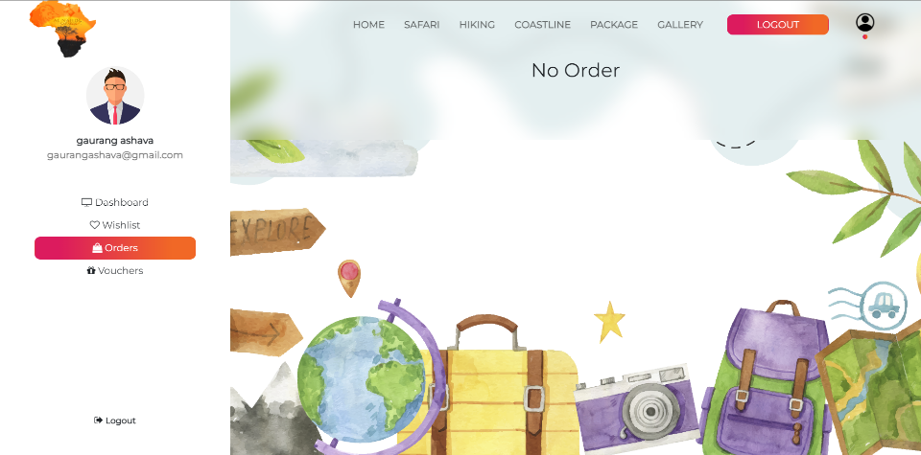

1. 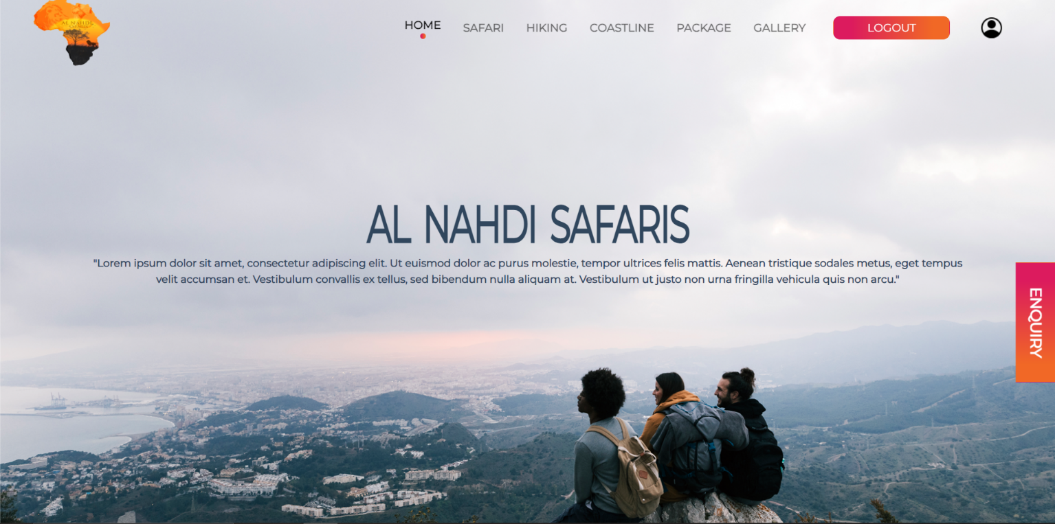**HOMEPAGE**
2. **ENQUIRY PAGE**

Step 1 => This Enquiry Page is used to know the details about the passenger.

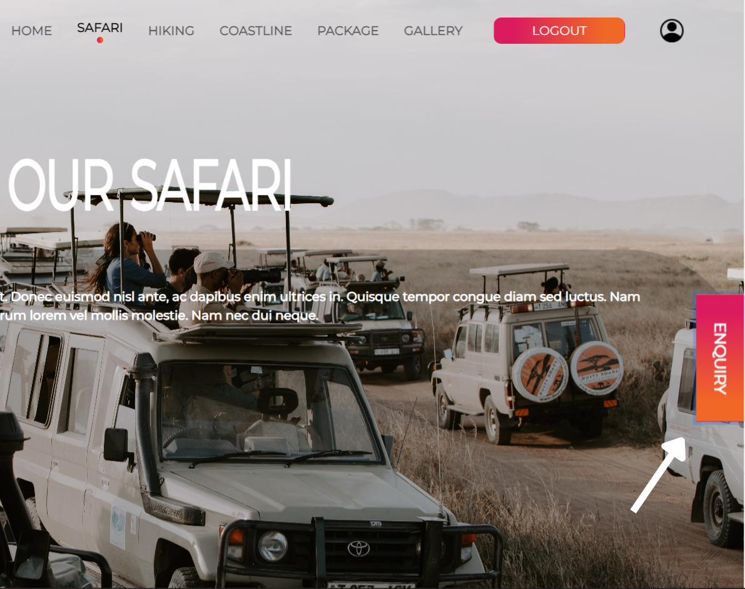

Step 2=> Details must be mentioned so that a flexible itinerary can be given to you for your selected tour.

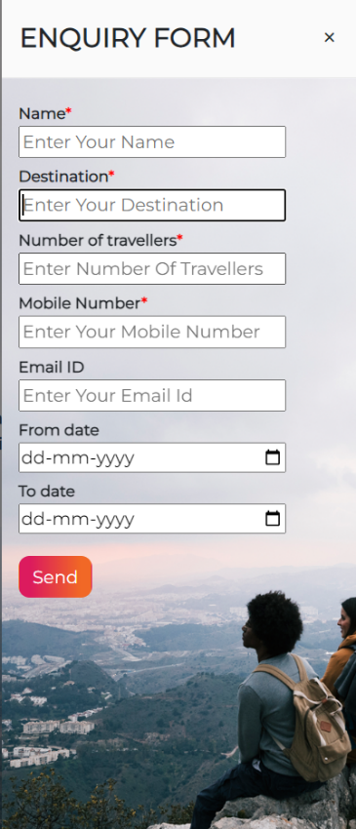

1. **SAFARI**

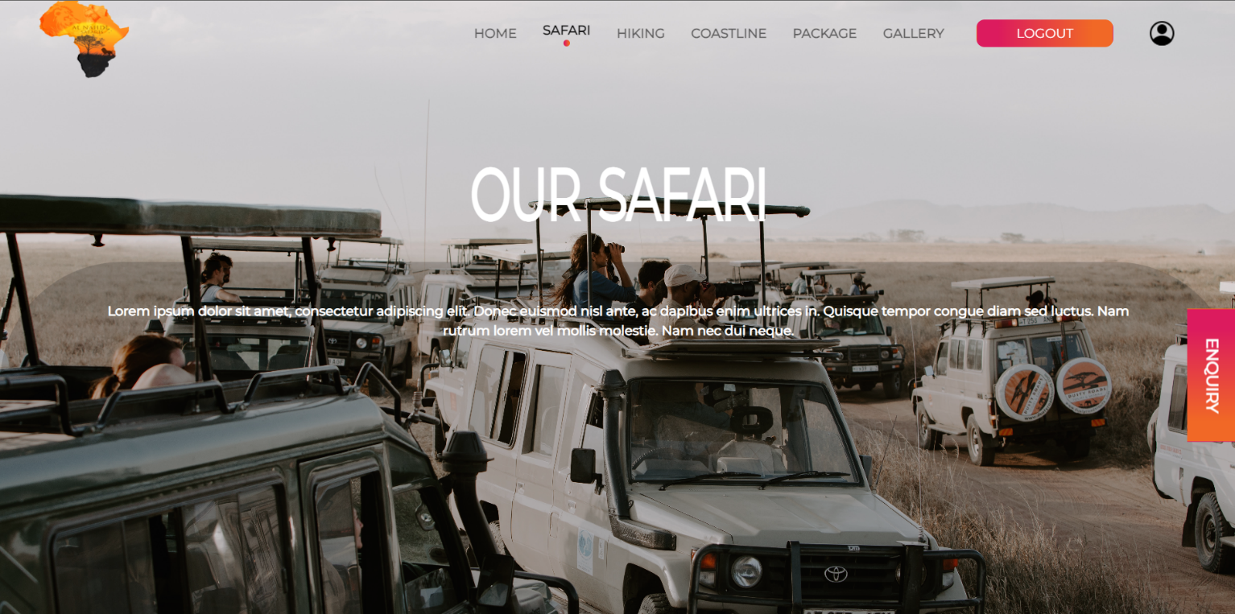Step 1 => This is the Safari Page and here we can see many safari expeditions.

Step 2 => Here the user has selected ‘Tarangire National Park’.

Step 3 => Click on ‘Explore’ to get to know more details about the expedition.

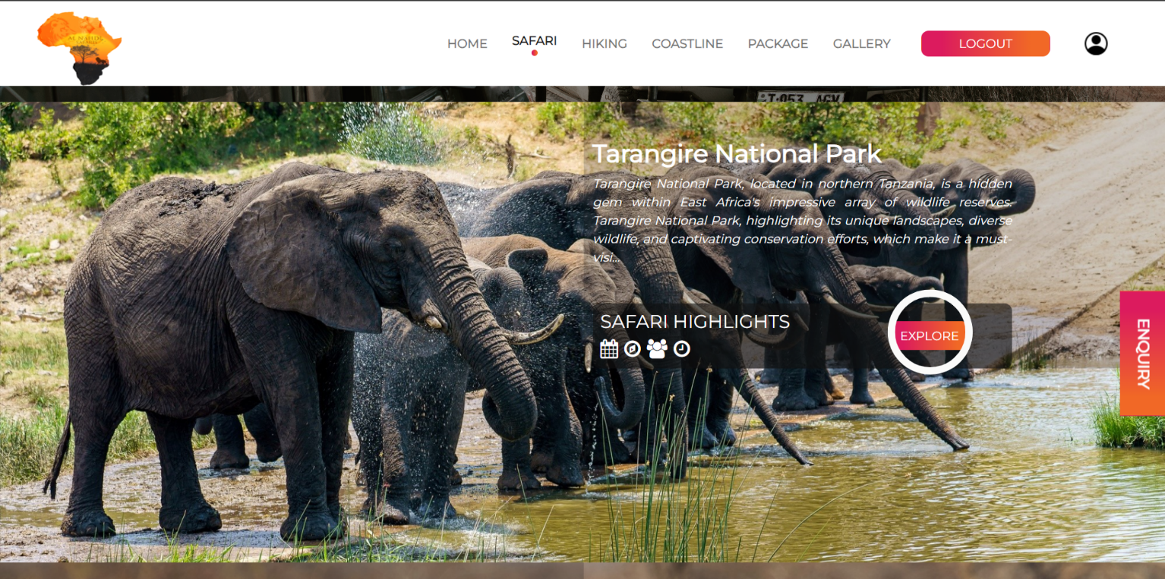

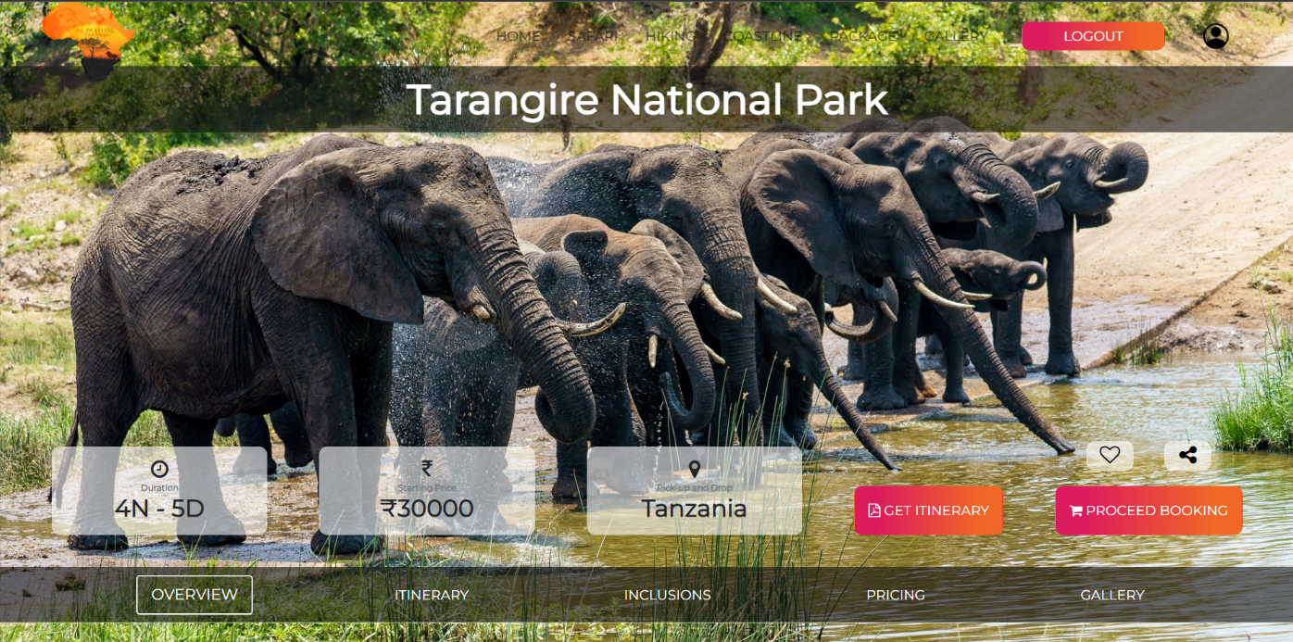Step 4 => On this page, the user can overview the expedition, can explore flexible itineraries, pricing, and images of the park.

Step 5 => After getting to know every piece of information, click on ‘Proceed Booking’ to book the tour.

Step 6 => The user can select the Tour Dates, facilities with the number of people, and comfortable boarding point.

Step 7 => While clicking on the ‘Book My Tour’ option, you will be redirected to the ‘Checkout’ Page.

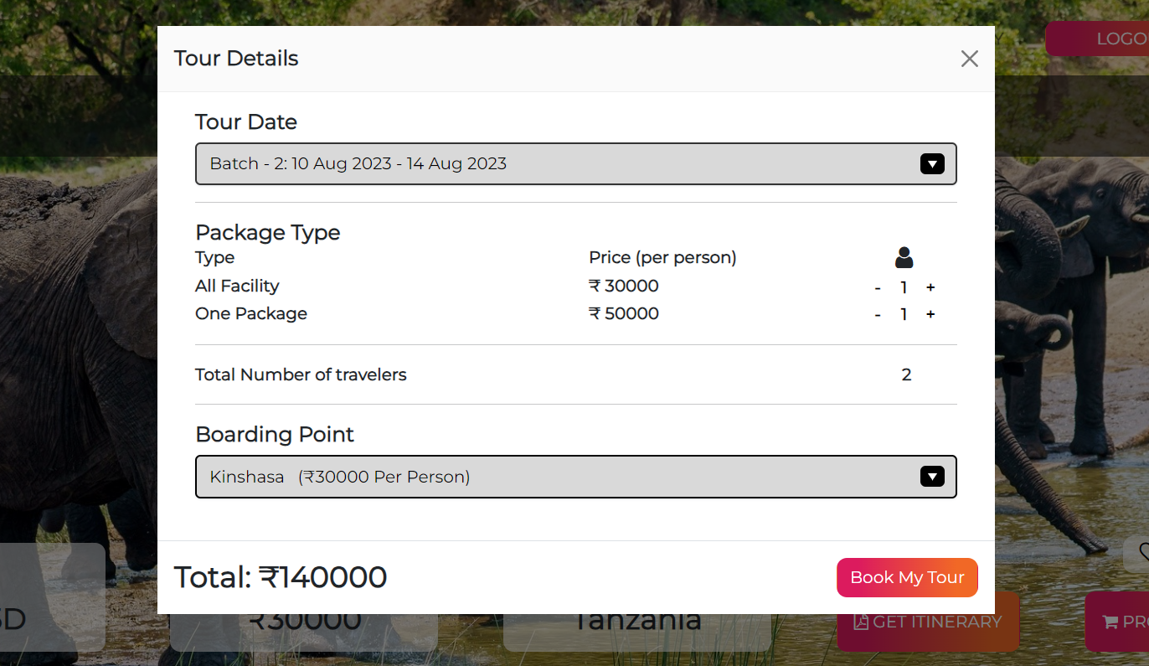

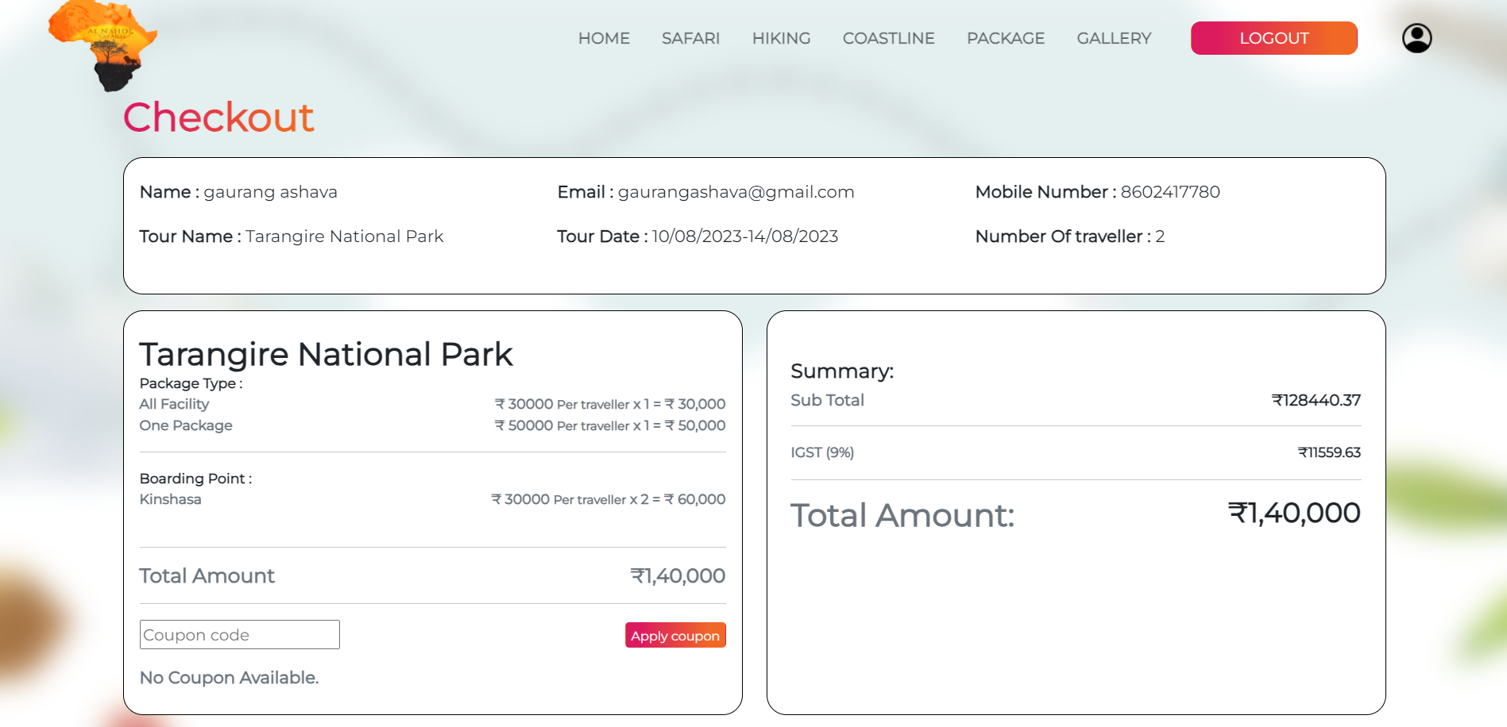

Step 8 => This is the page where you can see the invoice, details of the passengers, and the amount. Below this page is the payment option.

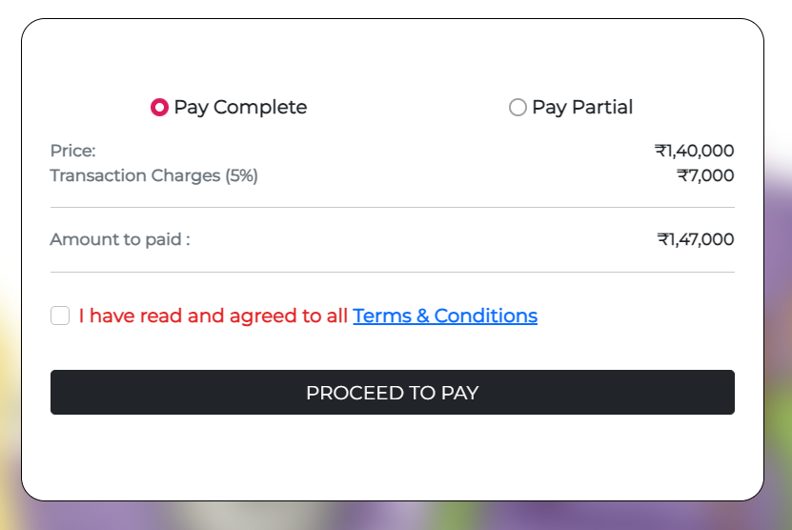Step 9 => Above is the Payment Page. Here the user can pay the whole amount partially or completely according to their own choice. Once Payment is done, go to the ‘Orders’ Page on the Profile Page.

1. **HIKING**

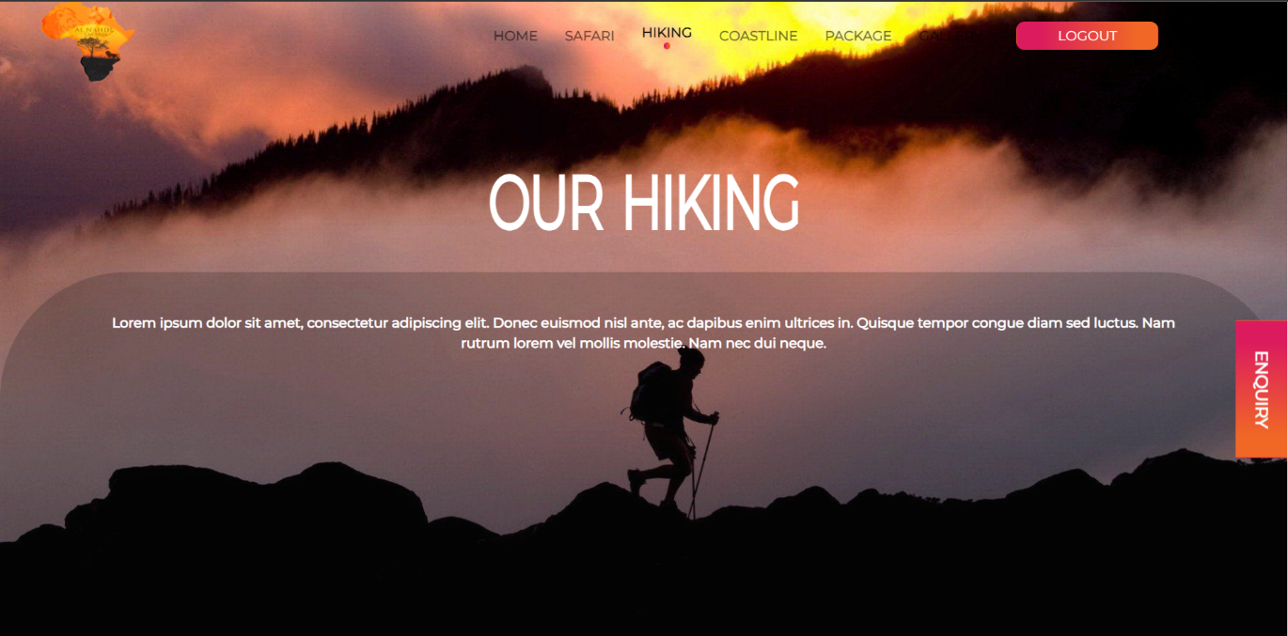Step 1 => This is the Hiking Page and here we can see many hiking expeditions.

Step 2 => Just like Safari, the procedure is the same.

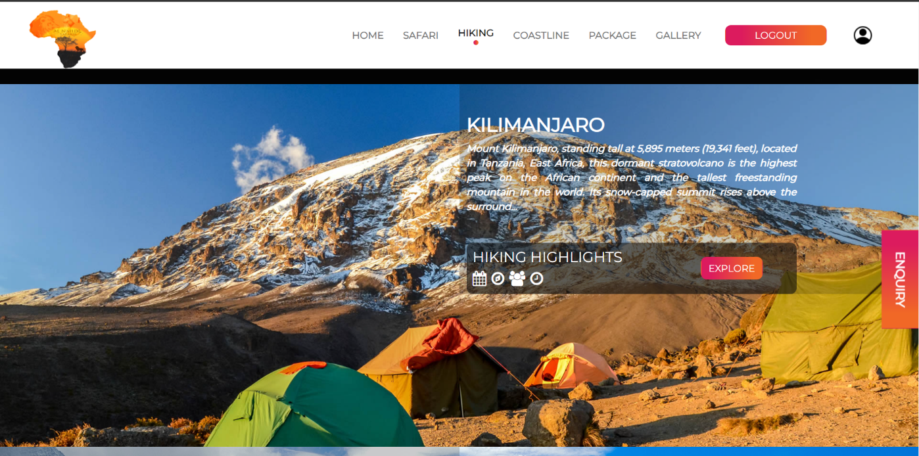

1. **COASTLINE**

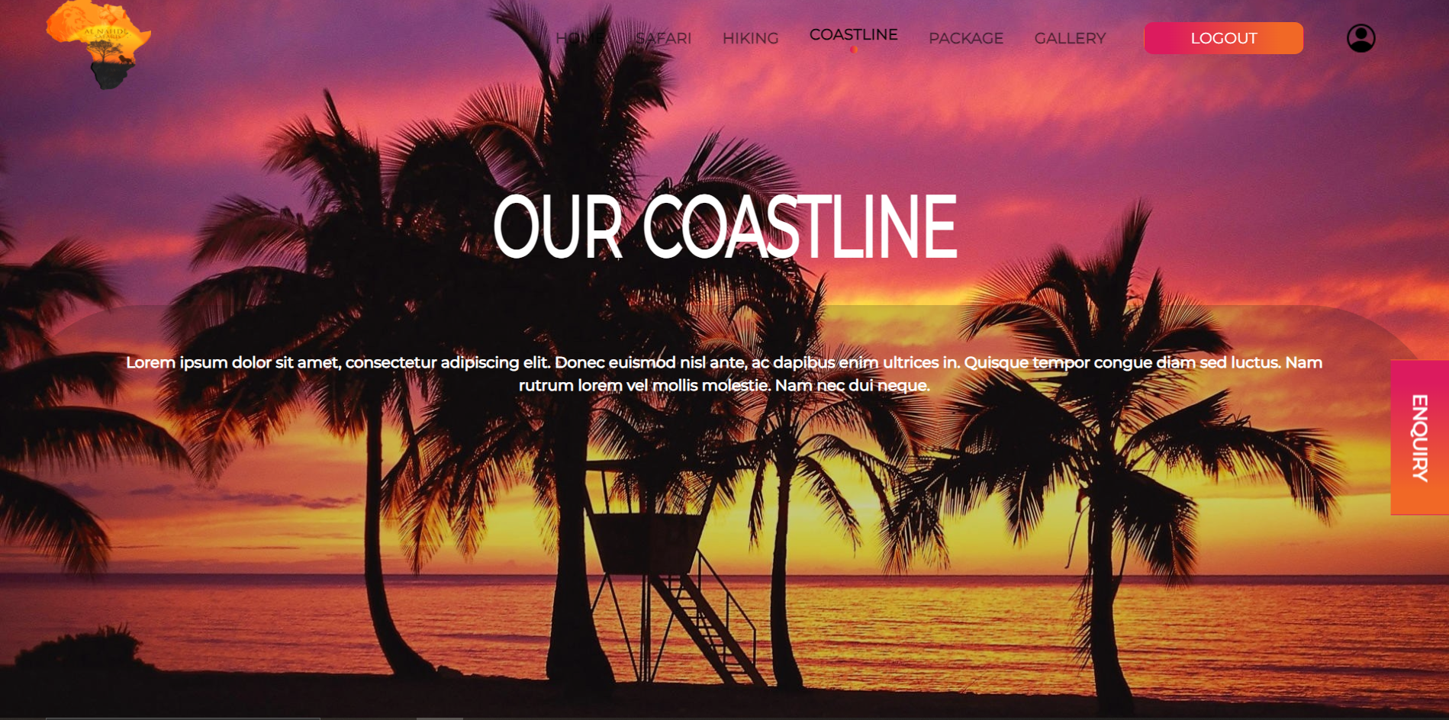Step 1 => This is the Coastline Page where a user can see many cruise expeditions.

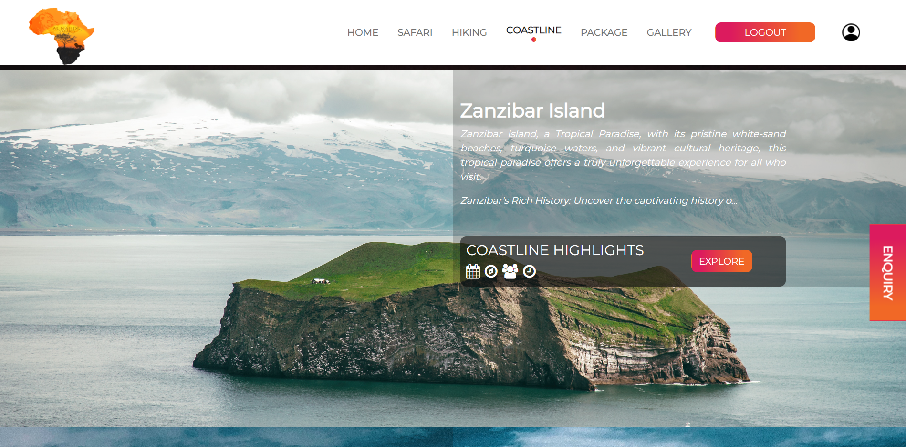Step 2 => Just like Safari, the procedure is the same.

1. **GALLERY**

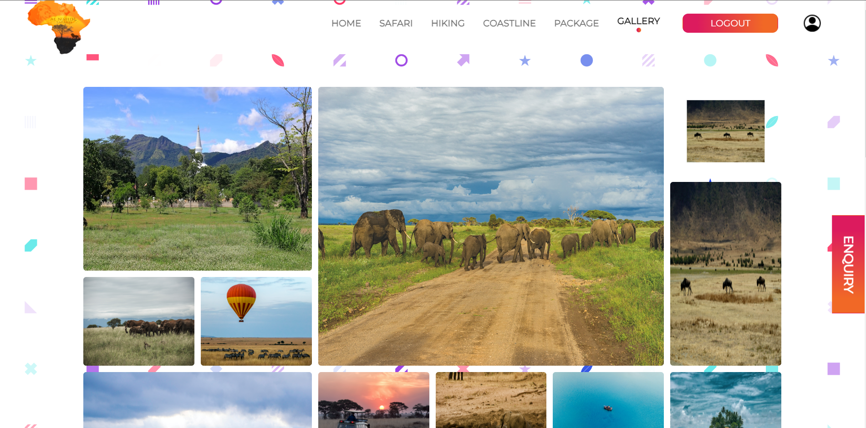Step 1 => This is the Gallery Page where a user can see all the uploaded photos.

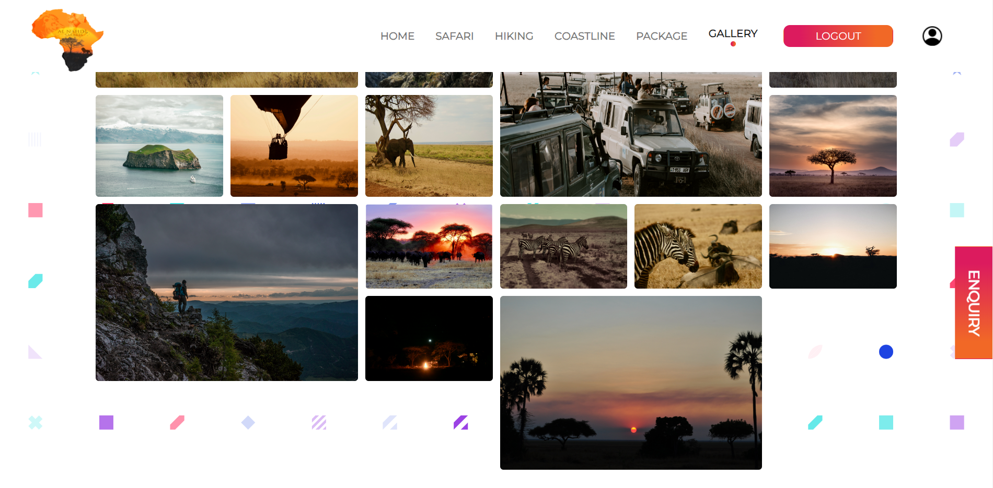

1. **ORDERS**

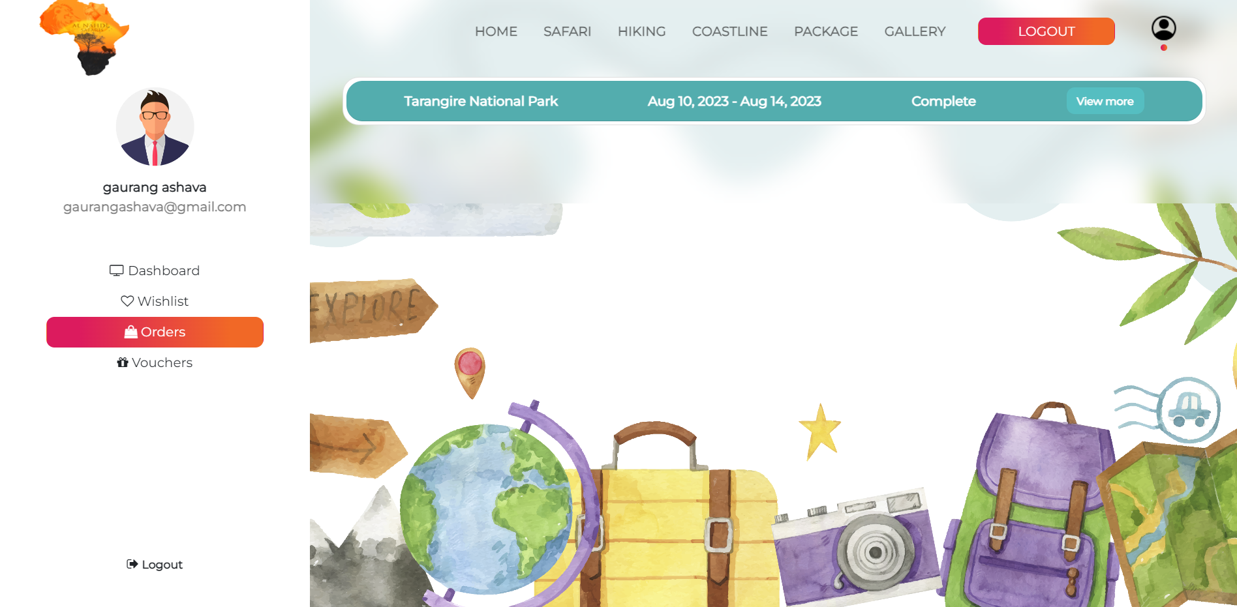Step 1 => This is the Order’s Page in which the user can see the package which was booked.

Step 2 => Clicking on ‘View More’ will give a detailed view of the package where Traveller Details are given, Add-Ons can be applied and there is an option to cancel the package.

